EXP 6.1

NAME: RAMA SUBRAMANIYAN.V
REG.NO: 192419051
COURSE CODE: ECA0910
COURSE NAME: DIGITAL SIGNAL PROCESSING
PRACTICAL LAB RESULTS

CODE:

clc;
clear;
close all;
%% Parameters
Fs = 1000; % Sampling frequency
f = 50; % Signal frequency
T = 0.1; % Duration
A = 1; % Amplitude
t = 0:1/Fs:T;
x = A*sin(2*pi*f*t);
Levels = [8 16 32];
figure(1)
subplot(4,1,1)
plot(t,x,'b','LineWidth',1.5)
title('Original Sinusoidal Signal')
xlabel('Time (s)')
ylabel('Amplitude')
axis([0 0.1 -1.1 1.1])
grid on
for k=1:length(Levels)
L = Levels(k);
% Step size
Delta = 2/(L-1);
% Uniform Quantization
xq = round((x+1)/Delta)*Delta - 1;
% Saturation
xq(xq>1)=1;
xq(xq<-1)=-1;
XQ{k}=xq;
subplot(4,1,k+1)
stairs(t,xq,'LineWidth',1.5)
title(['Quantized Signal (' num2str(L) ' Levels)'])
xlabel('Time (s)')
ylabel('Amplitude')
axis([0 0.1 -1.1 1.1])
grid on
end
figure(2)
for k=1:length(Levels)
e=x-XQ{k};
subplot(3,1,k)
plot(t,e,'LineWidth',0.8)
title(['Quantization Error (' num2str(Levels(k)) ' Levels)'])
xlabel('Time (s)')
ylabel('Error')
xlim([0 0.1])
grid on
end

OUTPUT:

Sampling Frequency, 𝐹𝑠 = 1000Hz
Signal Frequency, 𝑓 = 50Hz
Time Duration = 0.1 s
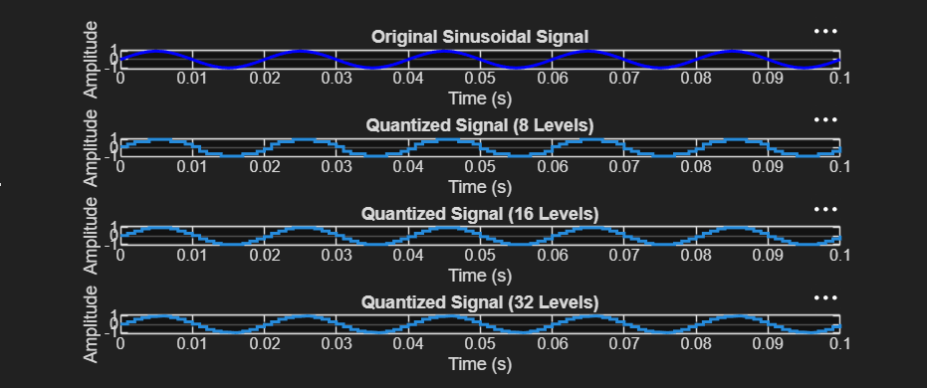

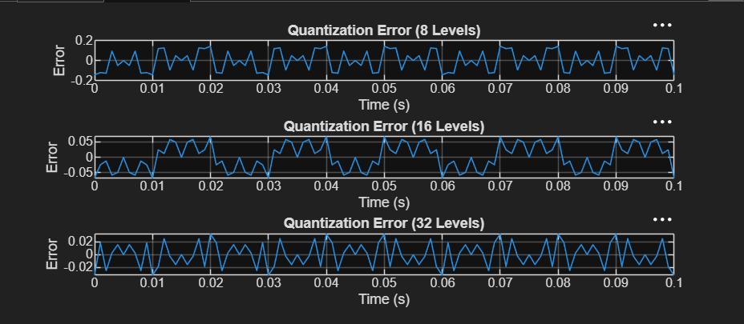

EXP 6.2

CODE:

clc; clear; close all
n=0:79;
x=sin(2*pi*n/40);
q=8;
xt=floor(x*q)/q;
xr=round(x*q)/q;
et=x-xt;
er=x-xr;
% Fig 1
figure
plot(n,x,'b',n,xr,'r','LineWidth',1.5)
grid on
title('Original vs Quantized')
legend('Original','Quantized')
% Fig 2
figure
plot(n,x,'b',n,xt,'r',n,xr,'g','LineWidth',1.5)
grid on
title('Truncation vs Rounding')
legend('Original','Truncated','Rounded')
% Fig 3
figure
stem(n,et,'r')
hold on
stem(n,er,'g')
grid on
title('Quantization Error')
legend('Truncation','Rounding')
% Fig 4
figure
bar([mean(et.^2) mean(er.^2)])
set(gca,'XTickLabel',{'Truncation','Rounding'})
grid on
title('MSE Comparison')
ylabel('MSE')

